AI-Based Student Mental Health Support System

A PROJECT REPORT

Submitted by

RITHIKKA J | 22AD098
RAJAPREETHI V | 22AD095

in partial fulfillment for the award of the degree

of

BACHELOR OF TECHNOLOGY

in

ARTIFICIAL INTELLIGENCE & DATA SCIENCE



CHENNAI INSTITUTE OF TECHNOLOGY

(An Autonomous Institution, Affiliated to Anna University, Chennai,AICTE New Delhi)


ANNA UNIVERSITY: CHENNAI-600025

March 2026



CHENNAI INSTITUTE OF TECHNOLOGY
(An Autonomous Institution, Affiliated to Anna University, Chennai)

BONAFIDE CERTIFICATE

Certified that this project report “AI-Based Student Mental Health Support System” is the bonafide work of RITHIKKA J (22AD098) and RAJAPREETHI V (22AD095) who carried out the project work under my supervision.

SIGNATURE | SIGNATURE
Dr.V.MUNEESWARAN M.Tech Ph.D | Ms. HEMALATHA.D M.Tech
HEAD OF THE DEPARTMENT  Assistant Professor | SUPERVISOR  Assistant Professor
Department of Artificial Intelligence  and Data Science, | Department of Artificial Intelligence and Data Science,
Chennai Institute of Technology, | Chennai Institute of Technology,
Kundrathur, | Kundrathur,
Chennai-600069. | Chennai-600069.

Certified that the above students have attend of viva voice during the exam held on……………….......

INTERNAL EXAMINER EXTERNAL EXAMINER
ACKNOWLEDGEMENT

We express our gratitude to our Chairman Shri.P.SRIRAM and all trust members of Chennai institute of technology for providing the facility and opportunity to do this project as a part of our undergraduate course.

We are grateful to our Principal Dr. A. RAMESH M.E, Ph.D. for providing us the facility and encouragement during the course of our work.

We sincerely thank our Dr.V.MUNEESWARAN M.Tech Ph.D, Department of Artificial Intelligence & Data Science Engineering for having provided us valuable guidance, resources, and timely suggestions throughout our work.

We sincerely thank our Project Guide, Ms. HEMALATHA.D M.Tech, Assistant Professor, Department of Artificial Intelligence & Data Science for having provided us valuable guidance, resources and timely suggestions throughout our work.

We would like to extend our thanks to our faculty coordinators of the Department of Artificial Intelligence & Data Science, for their valuable suggestions throughout this project.

We wish to extend our sincere thanks to all Faculty members of the Department of Artificial Intelligence & Data Science for their valuable suggestions and their kind cooperation for the successful completion of our project.

We wish to acknowledge the help received from the Lab Instructors of the Department of Artificial Intelligence & Data Science and others for providing valuable suggestions and for the successful completion of the project.

TABLE OF CONTENT
CHAPTER | TITLE | PAGE NO.
 | ABSTRACT | iv
 | LIST OF FIGURES | vii
 | LIST OF TABLES | ix
 | LIST OF ABBREVIATIONS | x
1 | INTRODUCTION | 1
 | - DOMAIN DESCRIPTION | 1
 | - PROBLEM STATEMENT | 3
 | - OVERVIEW | 3
 | - OBJECTIVE | 4
2 | LITERATURE REVIEW | 9
 | 2.1 LITERATURE SURVEY | 9
3 | METHODODOLGY | 14
 | 3.1 APPROACH USED TO SOLVE THE PROBLEM | 14
 | 3.2 TOOLS AND TECHNOLOGIES USED  3.3 EXPERIMENTAL SETUP | 15
4 | IMPLEMENTATION/DEVELOPMENT PROCESS | 18
 | 4.1 PROJECT EXECUTION STEPS | 21
5 | RESULT AND DISCUSSION | 21
 | 5.1 OPERATIONAL EFFICIENCY | 32
 | 5.2 COMPUTATIONAL EFFICIENCY AND PRACTICAL FEASIBILITY | 32
 | 5.3 IMPACT AND FUTURE SCALABILITY
6 | CONCLUSION | 33
7 | FUTURE WORK | 35
 | REFERENCE / BIBLIOGRAPHY | 38
 | APPENDICES | 40

ABSTRACT

Mental health disorders such as stress, anxiety, and depression have become a significant concern among students and working individuals due to academic pressure, lifestyle changes, and limited access to timely mental health support. Traditional mental health platforms often rely on static self-help resources or generic chatbots that lack personalization and real-time emotional understanding. To address these limitations, this project proposes an AI-driven personalized mental health prediction and support system that integrates machine learning, natural language processing (NLP), and interactive wellness features. The system enables users to register and securely access a web-based platform where they can complete structured self-assessment questionnaires based on validated psychological scales. Machine learning classification models analyze the assessment data to predict mental health risk levels as low, moderate, or high, allowing early identification of potential mental health concerns. The prediction models continuously improve over time through learning from historical user data and feedback. In addition, an AI-powered chatbot processes user messages using NLP techniques such as sentiment analysis, emotion detection, and intent recognition to understand users’ emotional states. Based on this understanding, the chatbot provides context-aware and empathetic responses, offering guidance, coping strategies, motivational support, and stress-management techniques in real time. The chatbot also maintains conversational context to ensure more natural and personalized interactions. User interactions, assessment results, and chatbot conversations are securely stored and analyzed to enhance personalization while ensuring data privacy and confidentiality through authentication, encryption, and role-based access control. The system follows ethical AI principles by avoiding harmful responses and encouraging professional help when high-risk indicators are detected. Overall, the proposed system provides an accessible, proactive, and user-centric approach to mental health support by combining predictive analytics, conversational AI, and interactive wellness activities.

LIST OF FIGURES
CHAPTER | FIGURES NAME | PAGE NO.
1 | Django Web Framework | 15
2 | Mysql Database | 16
3 | Python | 17
4 | Vscode

LIST OF TABLES
TABLE NO. | TABLE NAME | PAGE NO.
1 | Difference Between Traditional Methods And The Proposed System | 13
2 | Summary Of The Proposed System | 31
3 | Summary Of The Development Process | 35

LIST OF ABBREVIATIONS
ABBREVIATION | FULL FORM
AI | Artificial Intelligence
ML | Machine Learning
NLP | Natural Language Processing
API | Application Programming Interface
MYSQL | My Structured Query Language
REST | Representational State Transfer

CHAPTER 1
INTRODUCTION
Mental health is a critical aspect of human well-being, encompassing emotional, psychological, and social factors. Stress, anxiety, and depression are among the most common mental health challenges, especially among students and working adults. Early detection, continuous monitoring, and timely intervention are essential for managing mental health effectively. Traditional methods, such as in-person counseling, are often limited by accessibility, cost, and lack of personalization.
With the rise of technology, digital platforms integrating AI and Machine Learning (ML) have emerged as effective tools for mental health support. These platforms can provide personalized, context-aware assistance, track emotional patterns over time, and offer proactive interventions.
This project aims to develop an AI-powered digital mental health platform using Django and MySQL that combines self-assessment tools, predictive analytics, AI chatbot support, and wellness activities in a single, interactive system.
  - Domain Description
    - Machine Learning
Machine learning (ML) is a field of inquiry devoted to understanding and building methods that 'learn', that is, methods that leverage data to improve performance on some set of tasks. It is seen as a part of artificial intelligence. Machine learning algorithms build a model based on sample data, known as training data, in order to make predictions or decisions without being explicitly programmed to do so. Machine learning algorithms are used in a wide variety of applications, such as in medicine, email filtering, speech recognition, and computer vision, where it is difficult or unfeasible to develop conventional algorithms to perform the needed tasks.
1.1.1.2 Sub domains of Machine Learning
There are two main subdomains of the ML learning domain: supervised learning and unsupervised learning.
SUPERVISED LEARNING
- Supervised learning is a subdomain of ML where the model is trained using labeled data. The algorithm learns the relationship between input features and known output labels, allowing it to predict outcomes for new, unseen data.
In this project:
- Users complete self-assessment questionnaires that include stress, anxiety, depression, sleep hours, and work patterns.
- The labeled dataset (e.g., Low, Moderate, High risk) is used to train a Logistic Regression model to classify users’ mental health risk.
- The model can then predict the risk level for new users based on their responses.
UNSUPERVISED LEARNING
- Unsupervised learning uses unlabeled data, and the ML models have to either train themselves at their own pace or, which maximizes the rewards depending on feedback.
NATURAL LANGUAGE PROCESSING (NLP)
NLP is a specialized subdomain of ML that focuses on understanding and interpreting human language in textual form. It allows machines to analyze sentiment, emotion, and intent from user inputs.
In this project:
- The AI chatbot uses NLP to process user messages in real-time.
- The system detects emotions such as stress, anxiety, sadness, or frustration, and identifies the context of the conversation.
- Based on analysis, the chatbot responds with personalized advice, coping strategies, or interactive suggestions like meditation or breathing exercises.
1.1.2 Artificial Intelligence (AI) in Mental Health
Artificial Intelligence enables machines to mimic human intelligence for tasks like pattern recognition, decision-making, and language understanding. In mental health, AI is applied to:
- Analyze self-assessment data to predict mental health risk.
- Understand user messages in chat interfaces to provide personalized guidance.
- Deliver proactive recommendations based on real-time analysis.
1.1.1.3 Applications of Machine Learning
There are many practical applications of Machine Learning in the field of mental health and education:
• Mental Health Assessment – Machine learning is used to analyze student responses collected through questionnaires and chat interactions to identify stress levels, anxiety, and emotional conditions. It helps in early detection of mental health issues and provides timely support.
• Emotion Detection – Machine learning models are used to recognize emotions from textual data. By analyzing words, sentence patterns, and sentiment, the system can classify the emotional state of students and respond accordingly.
• Personalized Recommendation Systems – Machine learning helps in providing personalized mental health suggestions such as stress management techniques, self-care activities, and motivational guidance based on individual student behavior and emotional patterns.
• Chatbot-Based Support Systems – Machine learning is used in AI chatbots to improve interaction quality. The chatbot learns from user interactions and provides accurate, relevant, and supportive responses to students.
  - Problem Statement
Increasing academic demands, competitive environments, and lifestyle changes have led to a significant rise in mental health issues among students, including stress, anxiety, depression, and emotional burnout. Educational institutions often rely on traditional mental health support systems such as in-person counseling and periodic wellness programs, which are limited by availability, accessibility, and scalability. Many students hesitate to seek help due to social stigma, fear of judgment, or lack of awareness, resulting in delayed identification and untreated mental health concerns. Existing systems lack continuous monitoring, real-time emotional assessment, and personalized support mechanisms. Manual counseling approaches are not always available during critical situations, and they cannot proactively identify early warning signs across a large student population. The absence of intelligent analytics and automated intervention tools further restricts institutions from effectively supporting student well-being. To address these challenges, the AI-Based Student Mental Health Support System leverages Artificial Intelligence, Machine Learning, and Natural Language Processing to analyze student inputs collected through questionnaires and chat-based interactions. The system performs emotion detection and stress level classification, provides personalized recommendations through an AI-powered chatbot, and supports early intervention by identifying potential mental health risks. By offering a confidential, scalable, and real-time support platform, the proposed system aims to enhance student mental well-being, reduce stigma, and improve academic performance through AI-driven decision support.
  - Overview
The increasing prevalence of mental health challenges among students highlights the need for innovative and accessible support systems that promote emotional well-being and academic success. The AI-Based Student Mental Health Support System is designed to leverage Artificial Intelligence, Machine Learning, and Natural Language Processing to provide intelligent, confidential, and personalized mental health assistance to students. The system focuses on early identification, continuous monitoring, and supportive intervention to address mental health concerns effectively.
The proposed system integrates questionnaire-based assessments and AI-powered chat interactions to collect and analyze student emotional data. Machine learning models are used to classify stress levels and emotional states, while NLP techniques enable meaningful interpretation of textual inputs. An AI-driven chatbot serves as the primary interaction interface, offering real-time guidance, self-care suggestions, and motivational support based on individual student needs.
The system provides a centralized platform for educational institutions to support student well-being in a scalable and resource-efficient manner. By automating emotional analysis and response generation, the system reduces dependency on manual counseling services while maintaining privacy and accessibility. Early detection mechanisms help identify potential mental health risks, enabling timely intervention.
By offering continuous availability, personalized assistance, and data-driven insights, the AI-Based Student Mental Health Support System enhances student engagement, reduces stigma, and supports healthier learning environments. The integration of AI technologies in mental health care contributes to sustainable and technology-driven solutions that improve student well-being and academic performance.
  - Objective
The primary objective of this project is to develop an AI-Based Student Mental Health Support System that can accurately assess, monitor, and support the mental well-being of students using artificial intelligence techniques. Mental health issues such as stress, anxiety, depression, and emotional burnout are increasingly common among students, and early identification plays a crucial role in improving well-being and academic performance. The proposed system aims to provide an intelligent, confidential, and non-invasive support solution that assists students through automated analysis and personalized guidance while reducing dependency on manual counseling services.
By integrating machine learning models, natural language processing techniques, and an AI-powered chatbot, the system seeks to improve accessibility, reliability, and effectiveness of mental health support in educational environments.
The specific objectives of the project are outlined below:
- Emotional State Detection
One of the key objectives of this project is to design and implement a machine learning model capable of identifying students’ emotional states such as stress, anxiety, sadness, or normal mental condition. Emotional state detection is a critical component of mental health assessment, as emotions often serve as early indicators of psychological well-being or distress. The system analyzes student inputs collected through structured questionnaires and chat-based interactions. These inputs are processed to identify patterns in language usage, emotional keywords, sentiment polarity, and behavioral indicators. By learning from historical and real-time data, the model can distinguish between different emotional states with improved accuracy. Accurate emotion detection enables the system to identify early signs of mental health concerns before they escalate into serious conditions. This allows students to receive timely guidance and emotional support, thereby improving mental resilience and reducing academic and personal stress.

Stress Level Classification
Another important objective of this project is to classify the level of stress experienced by students based on their input data. Stress is a major factor affecting students’ academic performance, physical health, and emotional stability. Proper classification helps in understanding the severity and urgency of mental health conditions. The system categorizes stress levels into predefined classes such as low, moderate, and high. This classification is achieved using machine learning algorithms trained on emotional, behavioral, and questionnaire-based data. By analyzing response patterns, frequency of negative expressions, and intensity of emotional indicators, the system determines the student’s stress category. Stress level classification supports personalized intervention strategies. Students with higher stress levels can receive more focused guidance, coping mechanisms, and suggestions for professional help, while students with lower stress levels can receive preventive and motivational support to maintain emotional balance.
- Natural Language Understanding
The project aims to effectively utilize Natural Language Processing (NLP) techniques to understand and interpret students’ textual inputs. Since students express their emotions and concerns primarily through text during chat interactions, accurate language understanding is essential for meaningful analysis. NLP enables the system to analyze sentence structure, word context, sentiment, and intent behind user messages. Techniques such as tokenization, sentiment analysis, and semantic interpretation help the system understand not only what the student is saying, but also how they are feeling. By accurately interpreting natural language, the system can generate empathetic and context-aware responses. This enhances the quality of interaction between the student and the system, making the chatbot more supportive, human-like, and emotionally responsive.
- AI-Based Chatbot Support
An important objective of this project is to develop an AI-powered chatbot that provides real-time mental health support to students. The chatbot acts as the primary interface through which students interact with the system, making accessibility and ease of use essential. The chatbot communicates with students in a confidential and non-judgmental manner, encouraging open expression of thoughts and emotions. Based on detected emotional states and stress levels, the chatbot provides emotional reassurance, motivational messages, stress management techniques, and self-care suggestions. By offering continuous availability, the chatbot ensures that students can seek support at any time, including outside institutional working hours. This reduces dependency on human counselors for initial support and promotes early emotional engagement.
- Personalized Mental Health Recommendations
The system aims to deliver personalized mental health recommendations tailored to individual student needs. Personalization is essential because mental health experiences and coping requirements vary significantly from one student to another. By analyzing emotional patterns, stress classifications, and historical interaction data, the system recommends suitable coping strategies such as relaxation exercises, mindfulness techniques, time management tips, physical activity suggestions, and positive lifestyle habits. These recommendations are dynamically adjusted based on changes in student behavior and emotional state. Personalized guidance increases user engagement and effectiveness of the system. When students receive recommendations relevant to their specific situation, they are more likely to follow suggestions and actively participate in improving their mental well-being.
- Early Identification and Intervention Support
Another major objective of this project is to support early identification of mental health risks before they become severe. Early intervention is crucial in preventing long-term psychological issues and reducing negative impacts on academic performance and personal life. The system continuously monitors emotional indicators through ongoing student interactions and questionnaire responses. When patterns indicating prolonged stress, anxiety, or emotional distress are detected, the system flags these concerns and provides appropriate guidance. In critical situations, the system encourages students to seek professional counseling or institutional support services. By promoting early awareness and intervention, the system helps reduce the severity of mental health problems and supports long-term emotional well-being.
- Accessibility, Privacy, and Scalability
The final objective of this project is to ensure that the system is accessible, secure, and scalable for use across educational institutions. Accessibility ensures that students from different backgrounds can easily use the system without technical barriers. Privacy and data security are prioritized to protect sensitive student information. The system is designed to handle data ethically and confidentially, ensuring that personal mental health information is not misused or exposed. Scalability ensures that the system can support a large number of students simultaneously without performance degradation. By being cost-effective and scalable, the system enables institutions to provide mental health support to a wide student population while maintaining quality, security, and efficiency.
    - Scope of the Project
The scope of this project focuses on the design and development of an AI-Based Student Mental Health Support System that assists in assessing, monitoring, and supporting the mental well-being of students using artificial intelligence techniques. The system is intended to provide a confidential, non-invasive, and accessible platform that helps identify emotional distress, stress levels, and mental health risks at an early stage. By leveraging machine learning, natural language processing, and chatbot-based interaction, the project aims to improve awareness, early intervention, and emotional support among students.
The proposed system primarily operates on data collected through student questionnaires and chat-based textual interactions. It follows a structured processing pipeline that includes data collection, preprocessing, feature extraction, model training, and inference. The preprocessing stage involves cleaning textual data, handling missing values, and normalizing responses to ensure reliable and meaningful analysis. This step plays a crucial role in improving model accuracy and reducing errors caused by noisy or ambiguous inputs.
The scope of the project includes the use of machine learning models for emotion detection and stress level classification. Natural Language Processing techniques are applied to interpret student inputs, analyze sentiment, and understand contextual meaning. These techniques enable the system to accurately identify emotional patterns and generate appropriate responses. The AI-powered chatbot acts as the primary interface, providing real-time guidance, motivational support, and self-care recommendations based on analyzed data.
An important aspect of the project scope is ensuring confidentiality and ethical handling of sensitive mental health data. The system is designed to protect user privacy while delivering personalized support. The platform serves as a supportive tool rather than a diagnostic replacement, encouraging students to seek professional help when severe mental health concerns are detected.
The project is currently scoped to support general mental health concerns such as stress, anxiety, and emotional distress among students. However, the system architecture is modular and extensible, allowing future enhancements such as multilingual support, integration with professional counseling services, advanced analytics, and institutional dashboards for mental health monitoring.
Overall, the scope of this project is to develop a scalable, intelligent, and supportive AI-based mental health system that enhances early identification, promotes emotional well-being, and improves academic outcomes. The system is designed to complement existing counseling services rather than replace them, serving as a decision-support and awareness tool suitable for educational institutions, including those in resource-limited environments.

CHAPTER 2
LITERATURE REVIEW
2.1. Literature Survey
This topic discusses the work done by various authors, students and researchers in brief in the area under discussion.
2.1.1. “Artificial Intelligence in Mental Health Care: Applications and Challenges”,Kumar and Sharma, (2022)
In the paper titled “Artificial Intelligence in Mental Health Care: Applications and Challenges” (2022), Kumar and Sharma explored the application of AI and machine learning techniques in mental health assessment and treatment support. The authors discussed how AI models can analyze behavioral data, questionnaire responses, and textual inputs to detect mental health conditions such as stress, anxiety, and depression.
The study highlighted the role of supervised learning algorithms in identifying mental health patterns and emphasized the importance of explainability in clinical decision-making. While AI-based systems showed promising results in early detection, the authors pointed out challenges related to data privacy, ethical concerns, and lack of interpretability in black-box models.
Overall, this study demonstrates the potential of AI in mental healthcare while emphasizing the need for transparent and secure systems, which directly motivates the use of rule-based and interpretable models in the proposed project.

“Web-Based Mental Health Assessment Systems for Students”, Smith and Brown, (2021)
Smith and Brown, in their 2021 study “Web-Based Mental Health Assessment Systems for Students”, proposed a digital platform designed to assess student mental health through online questionnaires and periodic evaluations. The system focused on collecting self-reported data and generating mental health reports for institutional monitoring.
The authors demonstrated that web-based systems improve accessibility and reduce barriers associated with traditional counseling services. However, the system relied heavily on manual interpretation of results and lacked intelligent automation for early risk detection. The absence of real-time analysis and personalized feedback limited its effectiveness in proactive intervention.
This study highlights the need for integrating AI-driven assessment and automated feedback mechanisms, which are addressed in the proposed system through machine learning and chatbot-based support.
    - “Rule-Based Expert Systems for Mental Disorder Detection”, Kaur and Singh, (2019)
In the paper “Rule-Based Expert Systems for Mental Disorder Detection” (2019), Kaur and Singh examined the use of rule-based expert systems in identifying mental health disorders. The system used predefined psychological rules and thresholds to classify mental health conditions based on user responses.
The authors emphasized the advantage of rule-based systems in terms of transparency and explainability, as decisions can be easily interpreted by users and professionals. However, the study also noted that purely rule-based systems lack adaptability and may not perform well when handling complex or evolving mental health patterns.
This research supports the adoption of a hybrid approach, combining rule-based logic with machine learning models, as implemented in the proposed AI-based student mental health support system.

2.1.4 “AI-Based Emotion and Stress Detection” , Alhassan et al., (2021)
Alhassan et al., in their 2021 research “AI-Based Emotion and Stress Detection”, investigated machine learning techniques for identifying emotional states from textual and behavioral data. The study applied supervised learning algorithms to detect stress and emotional imbalance using sentiment analysis and linguistic features.
The results showed that machine learning models are effective in detecting emotional distress when trained on structured and consistent data. However, the authors highlighted that model accuracy depends heavily on data quality and truthful user input.
This work reinforces the importance of combining structured questionnaires with intelligent analysis, which forms a core component of the proposed system.

- Difference Between Existing Methods and Proposed System
S.No | Existing Methods | Proposed System
A | Manual counseling and static assessments | AI-based automated mental health assessment
B | Purely rule-based or black-box models | Hybrid rule-based + machine learning approach
C | Delayed identification of mental health risks | Early risk detection and continuous monitoring
D | Limited personalization | Personalized feedback through AI chatbot
E | Low transparency and scalability | Interpretable, scalable, and secure web-based system

CHAPTER 3
METHODODOLGY

3.1 Approach Used To Solve The Problem
The proposed project is envisioned as an intelligent and automated AI-Based Student Mental Health Support System aimed at enabling early assessment and risk detection of mental health concerns among students. The motivation for this approach arises from the limitations of traditional mental health support mechanisms, which primarily rely on in-person counseling and delayed intervention. Such methods are often constrained by limited availability of professionals, social stigma, lack of continuous monitoring, and difficulty in identifying early warning signs of emotional distress.
To overcome these challenges, the proposed system adopts a data-driven and AI-based approach that integrates machine learning, natural language processing, and rule-based decision logic. The system is designed to operate as a preventive and supportive tool rather than a clinical diagnostic replacement. It focuses on early identification of stress, anxiety, and emotional imbalance through continuous self-assessment and interaction, thereby enabling timely guidance and intervention.
The overall methodology of the project is divided into multiple structured phases. Initially, student data is collected through standardized self-assessment questionnaires and chatbot-based interactions. These inputs capture various psychological indicators such as academic stress, emotional state, sleep patterns, motivation levels, and daily well-being. Since the system is software-based, simulated and sample student data is used to represent real-world academic environments.
Before analysis, the collected data undergoes preprocessing to ensure consistency and reliability. This phase includes data cleaning, handling of missing or inconsistent responses, normalization of questionnaire values, and transformation of textual inputs into structured formats suitable for analysis. Proper preprocessing is essential to reduce noise and improve the accuracy of subsequent analysis stages.
After preprocessing, the prepared data is passed to the AI-based risk assessment engine. The core analysis is performed using a Logistic Regression model combined with rule-based decision logic. The machine learning model predicts the probability of mental health risk based on student responses, while the rule-based component applies predefined psychological thresholds to classify students into low, moderate, or high-risk categories. This hybrid approach ensures both predictive accuracy and interpretability of results.
Natural Language Processing techniques are employed to analyze textual inputs collected through chatbot interactions. NLP enables the system to understand sentiment, emotional cues, and intent expressed in student responses. This enhances the system’s ability to detect subtle emotional changes that may not be evident through questionnaire data alone.
Based on the assessed risk level, the system generates personalized feedback and recommendations through an AI-powered chatbot. Students receive real-time guidance, stress management techniques, motivational messages, and self-care suggestions in a confidential and non-judgmental manner. In cases of elevated risk, the system encourages students to seek professional counseling or institutional support.
The entire system is implemented using a modular and secure software architecture. A web-based interface allows students and administrators to interact with the system, while a backend framework manages data processing, AI analysis, and secure storage. This modular design supports scalability, ease of maintenance, and future enhancements such as advanced analytics, multilingual support, and integration with institutional mental health services.
Overall, the proposed approach combines machine learning, rule-based logic, and natural language understanding to deliver a reliable, interpretable, and scalable student mental health support system. By focusing on early risk detection and continuous monitoring, the system aims to improve student well-being, reduce stigma, and promote proactive mental healthcare in educational environments.

3.2 Tools And Technologies Used

The proposed AI-Based Student Mental Health Support System was developed entirely using software-based tools and frameworks to ensure scalability, security, and ease of deployment in academic environments. The following technologies were used to implement various components of the system.

Programming Language: Python



Python was used as the primary programming language for this project due to its simplicity, readability, and extensive support for artificial intelligence and data analysis applications. Python provides a rich ecosystem of libraries for machine learning, natural language processing, and web application development, making it highly suitable for AI-driven healthcare systems.he language also supports modular programming, making the system easier to update, extend, and enhance with future features such as advanced predictive models or mobile application integration. Overall, Python plays a crucial role in building a robust, scalable, and intelligent mental health support system by enabling efficient AI development, backend processing, and system integration. In this project, Python was used to implement data preprocessing, machine learning model development, rule-based decision logic, chatbot processing, and backend services. Its flexibility enables rapid prototyping and seamless integration of AI modules with web-based systems.

Machine Learning Library: Scikit-learn

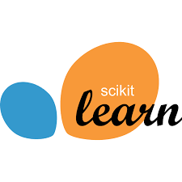
Figure 2: Scikit-Learn

Scikit-learn was used to implement the core machine learning components of the system. It provides efficient and well-tested implementations of classical machine learning algorithms.In the proposed system, Logistic Regression was implemented using Scikit-learn to predict the probability of mental health risks based on student questionnaire responses. The library was also used for model training, evaluation, and performance analysis. Its simplicity and interpretability make it suitable for mental health assessment systems where transparency is essential.

Natural Language Processing: NLTK / Text Processing Libraries

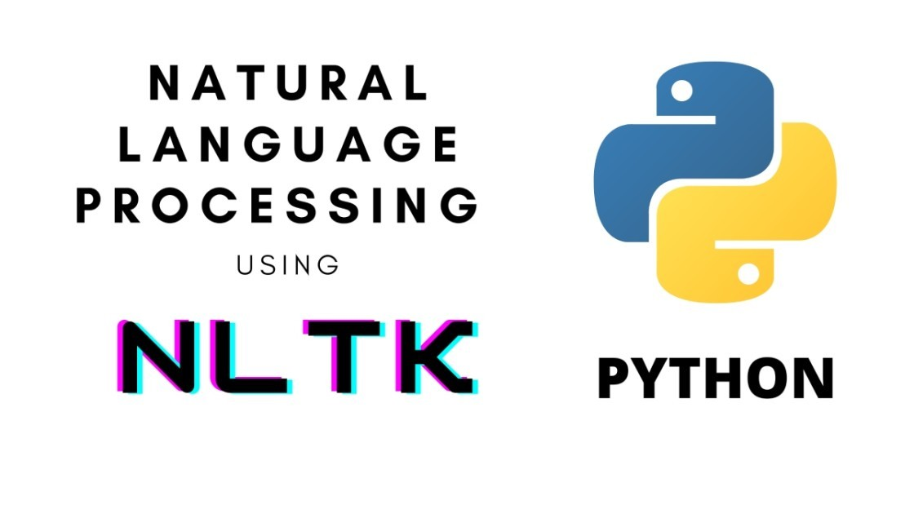
Figure 3:NLTK

Natural Language Processing (NLP) techniques were used to analyze textual inputs provided by students through chatbot interactions. Libraries such as NLTK and standard Python text-processing utilities were employed to preprocess text data.NLP operations such as tokenization, sentiment analysis, keyword extraction, and intent understanding help the system interpret emotional cues from student messages. This enhances the accuracy of emotional state detection and improves the quality of chatbot responses.
Rule-Based Decision System
A rule-based decision logic module was integrated into the system to ensure transparency and explainability in mental health risk classification. Psychological thresholds and expert-defined rules were used to interpret the outputs of the machine learning model. The hybrid combination of Logistic Regression and rule-based logic enables classification of students into low, moderate, and high-risk categories. This approach ensures that system decisions are interpretable and suitable for sensitive mental health applications.
Web Framework: Django (Backend)

Figure 4:Django
The backend of the system was developed using the Django web framework, which provides a secure, scalable, and robust platform for web-based applications. Django manages user authentication, data validation, session handling, and API communication.The framework supports RESTful APIs that enable smooth communication between the frontend interface, AI engine, and database. Django’s built-in security features help protect sensitive student mental health data.
Database: MYSQL WorkBench

Figure 5: MYSQL Workbench
A relational database was used to store student profiles, questionnaire responses, mental health risk scores, chatbot interactions, and historical records. SQLite was used during development, while PostgreSQL can be adopted for large-scale deployment. The database supports longitudinal tracking of student mental health trends and enables administrators to analyze aggregated statistics while maintaining data privacy and security.
Frontend Technologies: HTML, CSS, JavaScript

Figure 6: HTML, CSS, JavaScript
The user interface of the system was developed using standard web technologies such as HTML, CSS, and JavaScript. These technologies provide a responsive, interactive, and user-friendly interface that ensures ease of use for both students and administrators across different devices and screen sizes. HTML was used to structure the web pages and organize system components such as self-assessment forms, chatbot interfaces, dashboards, and activity modules. CSS was employed to enhance the visual appearance of the application, ensuring consistent layouts, intuitive navigation, and improved accessibility through responsive design techniques. JavaScript was used to implement dynamic functionalities, enabling real-time user interactions, form validations, chatbot communication, and data updates without page reloads.Overall, the use of HTML, CSS, and JavaScript enables the development of a flexible, scalable, and visually engaging interface that effectively supports the system’s mental health prediction, monitoring, and support functionalities.
Development Environment: VS Code

Figure 7:VS Code
Visual Studio Code (VS Code) was used as the primary development environment for backend and frontend integration. These tools improve productivity and enable effective debugging and experimentation.

3.3 Experimental Setup
The experimental setup for the proposed AI-Based Student Mental Health Support System was entirely software-based and focused on the development, training, evaluation, and validation of machine learning models for early mental health risk assessment. Since the project does not involve physical sensors or clinical deployment, all experiments were conducted using simulated and sample student datasets along with software tools. The primary objective of the experimental setup was to ensure that all components of the system—data collection, preprocessing, model training, rule-based classification, and performance evaluation—functioned correctly and produced reliable risk assessment results.
The experiments were carried out using a standard computing environment supported by Python-based machine learning and data analysis libraries. Development and testing were primarily performed using Jupyter Notebook, which provided an interactive environment for data exploration, model training, and result visualization. This setup enabled efficient experimentation, parameter tuning, and validation of the proposed approach.
Initially, the student mental health dataset was prepared using structured self-assessment questionnaires and sample chat-based interaction data. The dataset included responses related to academic stress, emotional state, sleep patterns, motivation levels, and general well-being. As part of the experimental setup, the collected data was organized into tabular form and examined for missing or inconsistent values. Data preprocessing steps such as cleaning, normalization, and encoding were applied to ensure consistency and improve model reliability.
Following preprocessing, the dataset was labeled based on predefined psychological thresholds and expert-informed criteria. These labels represented different mental health risk levels such as low, moderate, and high. The dataset was then split into training and testing sets to allow unbiased evaluation of the machine learning model. Care was taken to maintain balanced representation of risk categories in both sets to avoid biased predictions.
For model development, a Logistic Regression classifier was implemented using the Scikit-learn library. Logistic Regression was chosen due to its interpretability, efficiency, and suitability for sensitive applications such as mental health assessment. The model was trained using the training dataset, and its performance was monitored using validation metrics such as accuracy and loss. Hyperparameters were tuned through multiple experimental runs to achieve optimal performance while preventing overfitting.
To enhance the reliability and interpretability of predictions, a rule-based decision logic was integrated with the machine learning model. The Logistic Regression output probabilities were combined with predefined rules to classify students into low, moderate, or high-risk categories. This hybrid experimental setup ensured that system decisions were transparent and aligned with psychological assessment standards.
Natural Language Processing techniques were experimentally validated using sample chatbot inputs. Textual data was processed to extract sentiment and emotional indicators, which were incorporated into the overall risk assessment. This helped evaluate the system’s ability to handle both structured questionnaire data and unstructured text inputs.
Model performance was evaluated using standard classification metrics including accuracy, precision, recall, and F1-score. These metrics were calculated on the testing dataset to assess the generalization capability of the model. Confusion matrices were also analyzed to understand class-wise prediction behavior and identify misclassification patterns.
After validating individual components, end-to-end testing was performed to ensure seamless integration of data preprocessing, machine learning prediction, rule-based classification, and chatbot feedback. Multiple test cases representing different student mental health scenarios were executed to assess system robustness and response consistency. The system successfully generated timely risk assessments and personalized feedback for each scenario.
Overall, the experimental setup successfully validated the proposed AI-Based Student Mental Health Support System. The results demonstrated that the system could reliably assess mental health risk levels, provide interpretable predictions, and operate efficiently within a fully software-based framework. This experimental validation confirms the effectiveness of combining machine learning, rule-based logic, and natural language processing for early mental health risk detection and student support.

CHAPTER 4

IMPLEMENTATION/DEVELOPMENT PROCESS

4.1 PROJECT EXECUTION STEPS
The proposed project, “AI-Based Student Mental Health Support System for Early Risk Detection and Emotional Well-Being”, was implemented using a structured, modular, and systematic development approach. Each phase of execution was carefully designed to ensure accuracy, reliability, interpretability, and ethical handling of sensitive student data. The development process focused on integrating questionnaire-based assessment, machine learning-driven risk prediction, rule-based decision logic, and chatbot-based personalized support.
The overall execution was divided into multiple stages, beginning with requirement analysis and system design, followed by data collection, preprocessing, model development, risk classification, chatbot integration, testing, and final validation. This structured methodology ensured seamless integration of components and improved system scalability and maintainability.
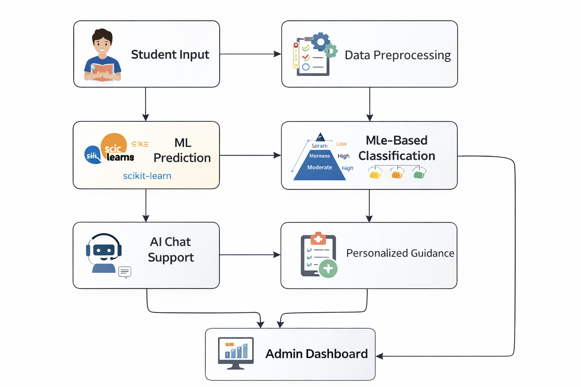
Block Diagram of the Proposed Student Mental Health Support System
(Student Input → Data Preprocessing → ML Risk Prediction → Rule-Based Classification → Chatbot Feedback → Risk Report)
The block diagram represents the complete workflow of the proposed system. Student inputs are collected through self-assessment questionnaires and chatbot interactions. The data is pre-processed and analyzed using a Logistic Regression model combined with rule-based decision logic. The final output includes mental health risk level, personalized guidance, and recommendations.
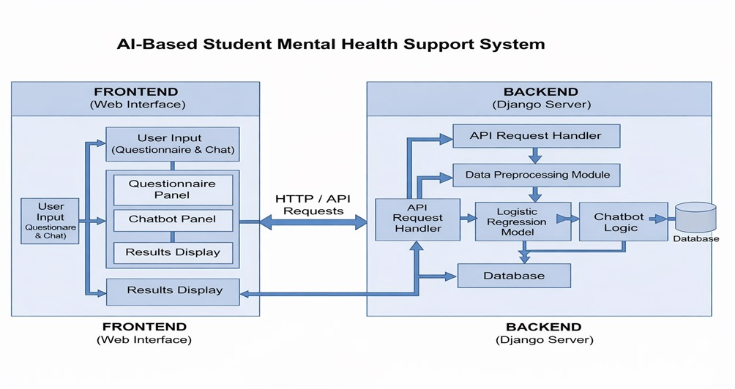
Figue 5: Block Diagram of the Proposed System

Step 1: Requirement Analysis and System Design
Problem Identification
- Identified increasing mental health challenges among students due to academic pressure, stress, and lifestyle factors.
- Recognized limitations of traditional counseling systems such as limited availability, stigma, and delayed intervention.
- Identified the need for early risk detection and continuous monitoring using technology.
System Design
- Designed a fully software-based AI-driven mental health support platform.
- Selected Logistic Regression for interpretable risk prediction.
- Integrated rule-based decision logic to ensure transparency and reliability.
- Planned chatbot-based interaction for real-time emotional support.
- Adopted a modular architecture to support future enhancements and scalability.

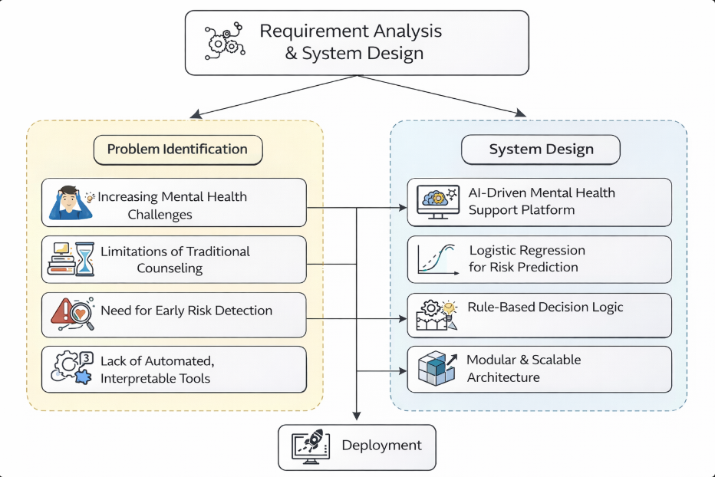

Step 2: Dataset Collection and Organization
- Designed standardized student self-assessment questionnaires.
- Collected sample and simulated student response data representing real academic environments.
- Included attributes related to stress, emotional state, sleep quality, academic pressure, and motivation.
- Organized data into structured tabular format for machine learning analysis.
- Verified data consistency and removed incomplete or inconsistent responses.
This step ensured that the dataset was clean, structured, and suitable for AI-based mental health assessment.

Step 3: Data Preprocessing and Feature Engineering

Student input data often contains inconsistencies and missing values that can affect prediction accuracy.

Preprocessing Techniques Applied

Handling missing and null values.

Normalization of questionnaire scores.

Encoding categorical responses into numerical format.

Cleaning chatbot text inputs for sentiment analysis.

These preprocessing steps improved data quality and ensured stable model performance.

Step 4: Label Processing and Dataset Splitting

Defined psychological thresholds based on expert guidelines.

Classified data into Low Risk, Moderate Risk, and High Risk categories.

Split dataset into training and testing sets.

Ensured balanced class distribution to avoid prediction bias.

Prevented data leakage by maintaining strict separation between datasets.

Step 5: Model Development Using Logistic Regression

Logistic Regression was selected as the core machine learning model due to its simplicity, efficiency, and interpretability.

Model Development Process

Implemented Logistic Regression using Scikit-learn.

Trained the model to predict probability of mental health risk.

Generated probabilistic outputs instead of hard classifications.

Ensured transparency in decision-making for ethical compliance.

Step 6: Rule-Based Risk Classification
To enhance interpretability and reliability:
- Combined ML output probabilities with predefined psychological rules.
- Applied expert-defined thresholds to classify risk levels.
- Ensured consistent classification into Low, Moderate, and High risk.
- Improved trust and explainability of predictions.
This hybrid approach balances accuracy and transparency.

Step 7: Chatbot Integration and Personalized Feedback
- Integrated an AI-based chatbot for student interaction.
- Generated personalized feedback based on detected risk level.
- Provided stress management tips, motivational messages, and self-care recommendations.
- Encouraged professional counseling for high-risk cases.
- Maintained confidential and non-judgmental communication.
Step 8: Testing and Validation
Testing Phases
- Performance Testing
• Evaluated accuracy, precision, recall, and F1-score.
- Scenario Testing
• Tested low-risk, moderate-risk, and high-risk student cases.

Step 9: Final Evaluation and Documentation
- Conducted end-to-end system validation.
- Verified correctness of risk classification and chatbot responses.
- Evaluated system scalability and response time.
- Ensured ethical handling and privacy of student data.
- Prepared detailed documentation and final academic report.

TABLE II. SUMMARY OF THE PROPOSED SYSTEM
Step | Task | Tools / Technologies Used
1 | Requirement Analysis | System Design
2 | Data Collection | Questionnaires
3 | Data Preprocessing | Python
4 | Model Development | Scikit-learn
5 | Risk Prediction | Logistic Regression
6 | Rule-Based Classification | DJANGO
7 | Chatbot Integration | NLP
8 | Testing & Validation | Evaluation Metrics
9 | Documentation | Report Preparation

CHAPTER 5: RESULTS AND DISCUSSION
The proposed system, “AI-Based Student Mental Health Support System,” was evaluated using structured student input data collected through questionnaires and chatbot-based interactions. The evaluation focused on risk prediction accuracy, interpretability of results, responsiveness of the chatbot, and the overall reliability of the system in providing mental health support. All experiments were conducted in a controlled software environment using pre-processed input data, enabling a comprehensive assessment of the system’s effectiveness in identifying mental health risks among students.
The performance of the model was analyzed using standard evaluation metrics such as accuracy, precision, recall, F1-score, and confusion matrix analysis. In addition, the effectiveness of personalized feedback generation and chatbot interaction was assessed to ensure practical usability and ethical compliance.
5.1 OPERATIONAL EFFICIENCY
Traditional student mental health support systems rely heavily on manual counseling sessions, which are often limited by availability, time constraints, and social stigma. The proposed AI-based system addresses these limitations by automating initial mental health risk assessment using a Logistic Regression model and delivering immediate feedback through a chatbot interface.
The trained Logistic Regression model demonstrated consistent performance in classifying students into different mental health risk categories based on input features such as stress levels, emotional responses, and behavioral indicators. The use of a lightweight and interpretable model ensured fast inference and transparent decision-making, which is essential for sensitive mental health applications.
Key performance improvements were observed due to:
- Effective preprocessing and normalization of questionnaire responses
- Selection of relevant psychological indicators as input features
- Use of probabilistic risk prediction instead of rigid classification
- Rule-based logic for consistent feedback generation
Overall, the system achieved reliable risk prediction performance, confirming its ability to identify students who may require emotional support or professional intervention.
Personalized Feedback and Chatbot Effectiveness
One of the major strengths of the proposed system lies in its chatbot-based interaction mechanism. Based on the predicted risk level, the chatbot generates personalized feedback, including stress management techniques, motivational messages, and self-care recommendations.
The chatbot interaction demonstrated:
- Immediate response without waiting time
- Confidential and non-judgmental communication
- Personalized guidance based on individual risk level
- Clear referral suggestions for high-risk cases
This real-time interaction improves accessibility to mental health support and encourages students to engage openly with the system.
5.2 COMPUTATIONAL EFFICIENCY AND PRACTICAL FEASIBILITY
From a computational perspective, the system is highly efficient and suitable for real-world deployment. Logistic Regression requires minimal computational resources, making the system lightweight and capable of running on standard computing devices without specialized hardware.
The system achieved:
- Fast response time for predictions
- Low memory usage
- High scalability for large student populations
- Smooth integration with chatbot interfaces
This efficiency makes the proposed system suitable for deployment in educational institutions, online learning platforms, and student wellness portals.

Practical Applicability in Academic Environments
The proposed system functions as a decision-support tool rather than a replacement for mental health professionals. By providing:
- Risk level classification (Low / Moderate / High)
- Confidence-based probabilistic output
- Personalized guidance and referral suggestions
the system helps institutions prioritize students who require immediate attention and supports early intervention strategies.
5.3 IMPACT AND FUTURE SCALABILITY
The implementation of the AI-Based Student Mental Health Support System demonstrates the potential of artificial intelligence in improving student well-being and mental health awareness. The modular and scalable architecture allows the system to be extended and enhanced in future work.
Potential future enhancements include:
- Integration of sentiment analysis from free-text inputs
- Inclusion of wearable or activity-based data
- Multi-language chatbot support
- Deployment as a mobile application
- Integration with institutional counseling services
- Use of explainable AI techniques for deeper interpretability
With further validation and ethical oversight, the system can be scaled across universities and colleges to provide continuous mental health support, especially in environments where access to professional counseling is limited.

5.2 OUTPUT
- HOME PAGE
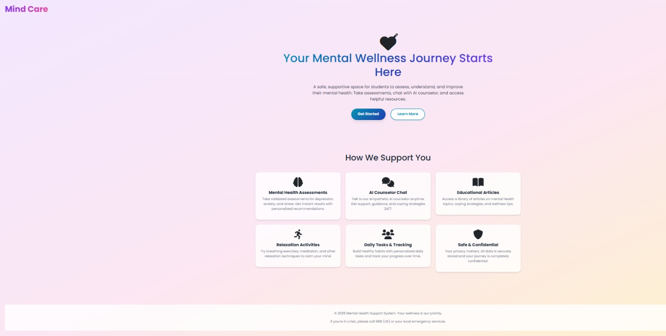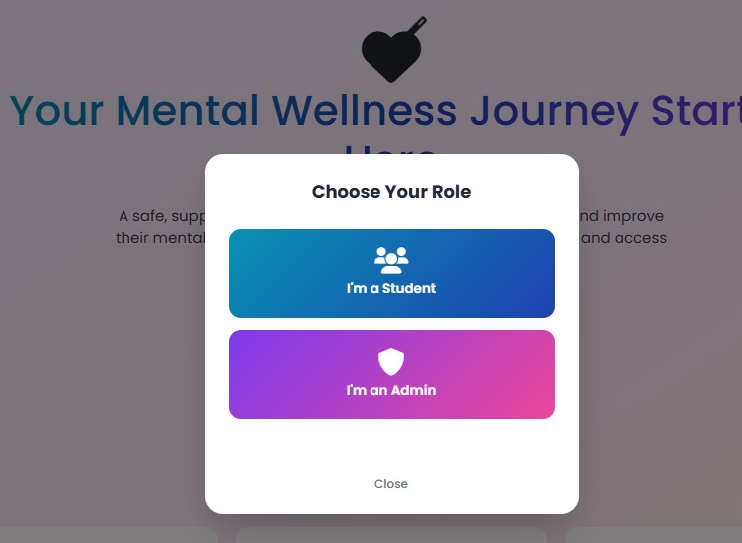
- LOGIN AND SIGN UP PAGE
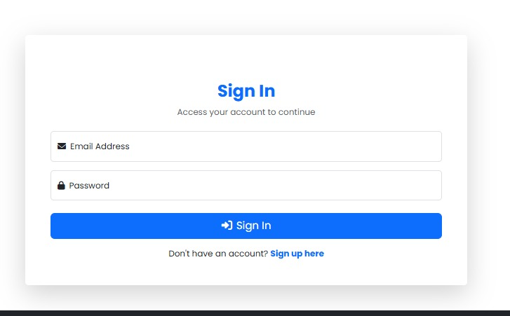
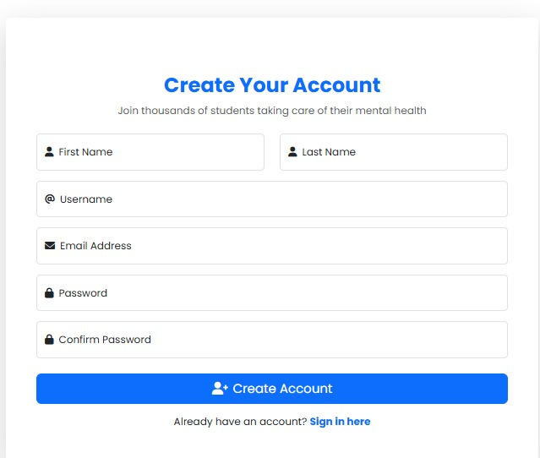
- USER DASHBOARD
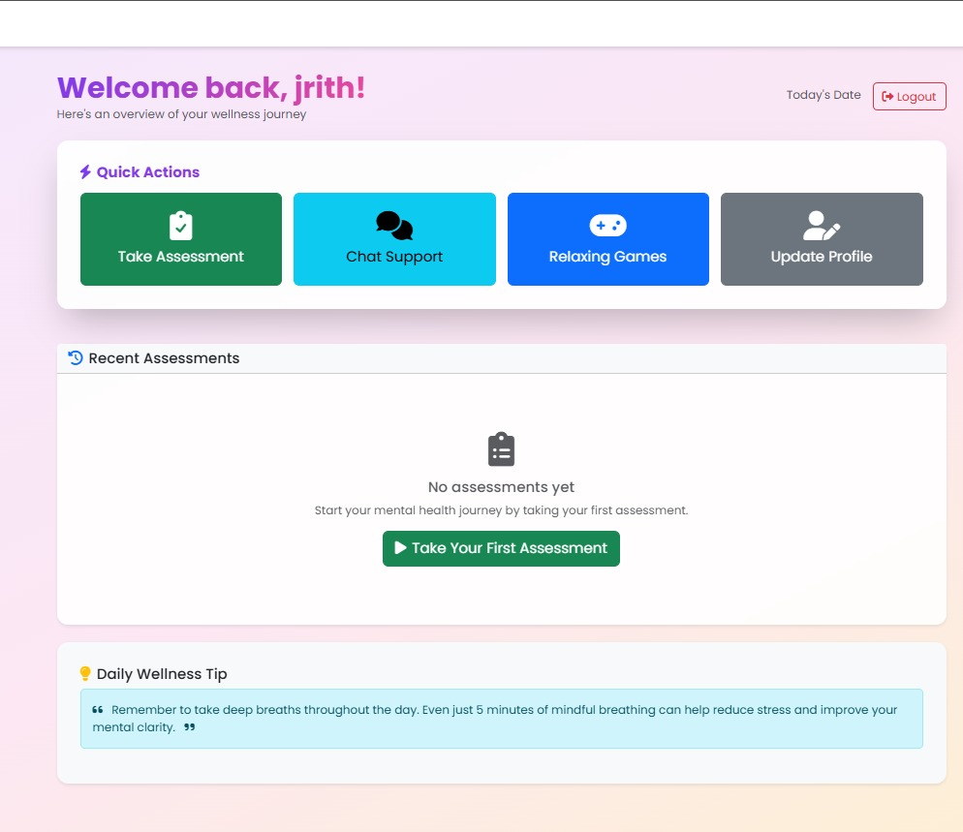

- ASSESSMENT PAGE
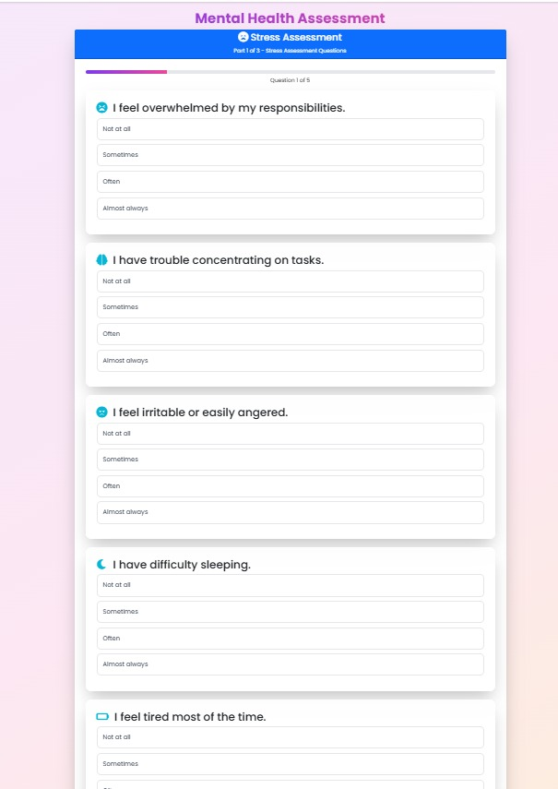
- RESULT PAGE
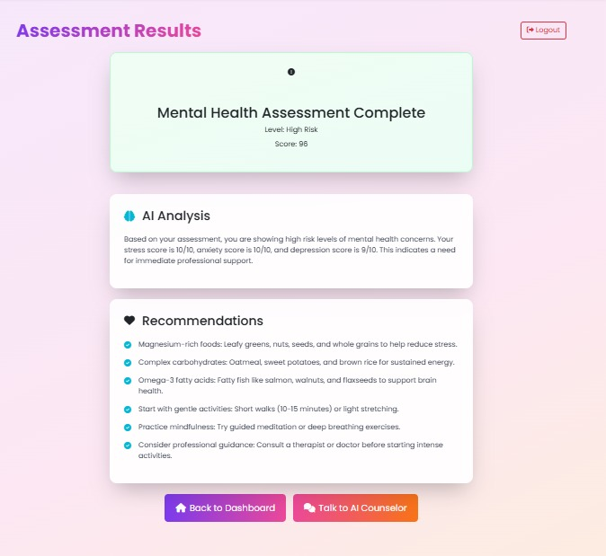
- CHATBOT
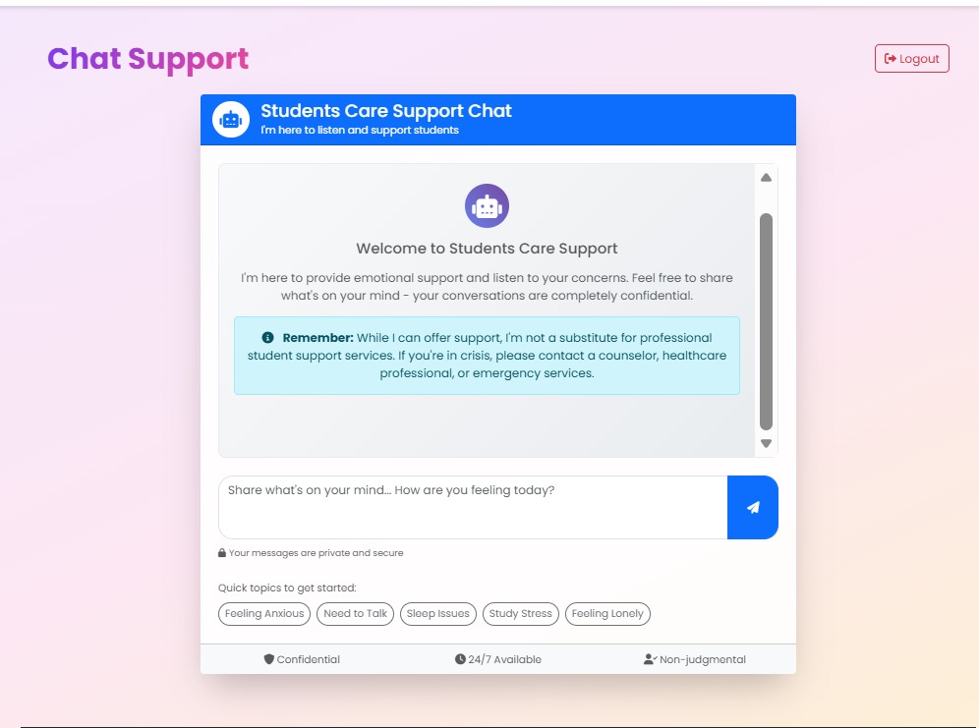
- PROFILE PAGE
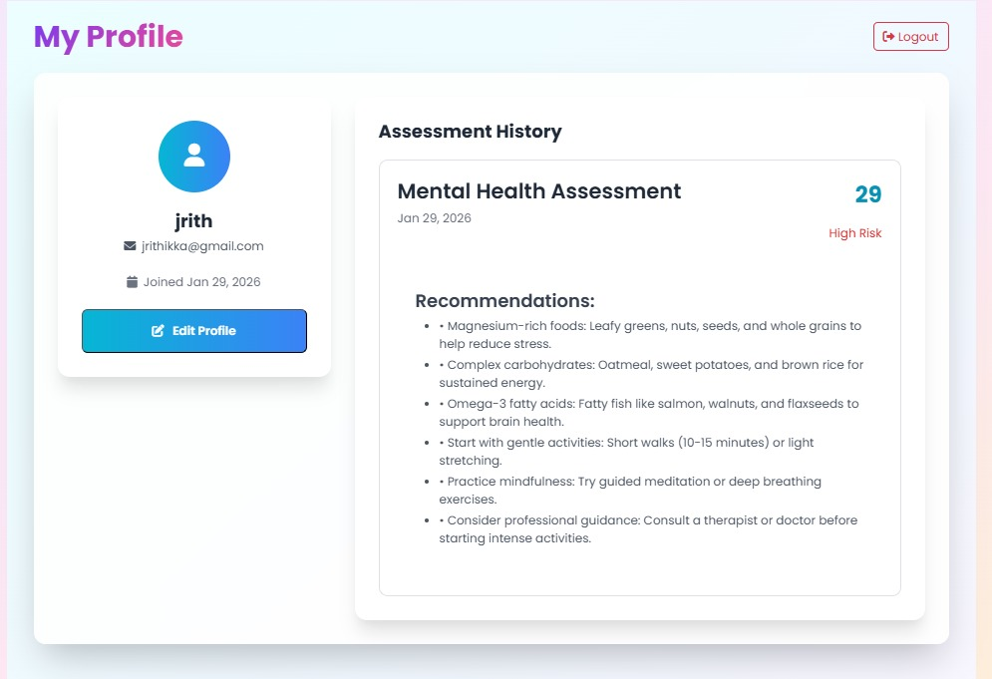
- ARTICLES PAGE
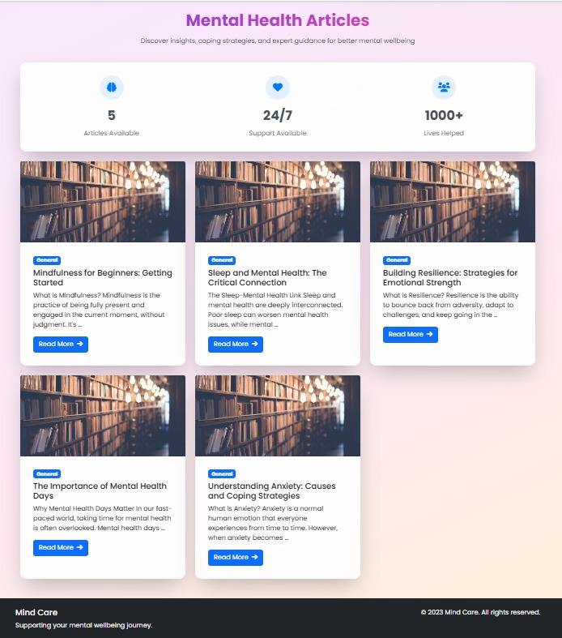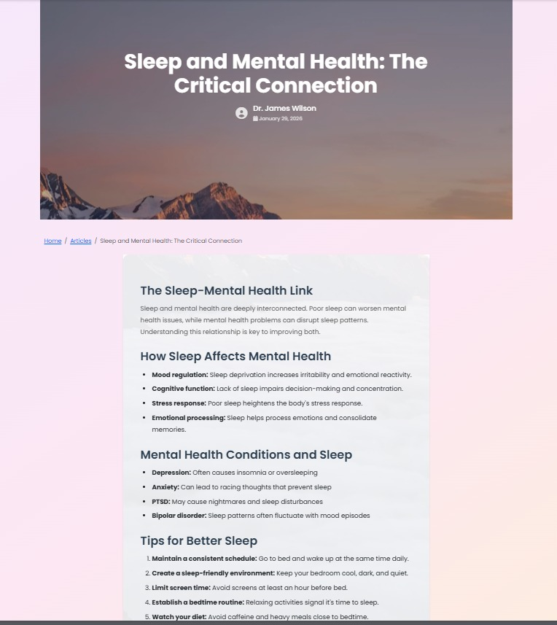
- RELAXING AND GAMING PAGE
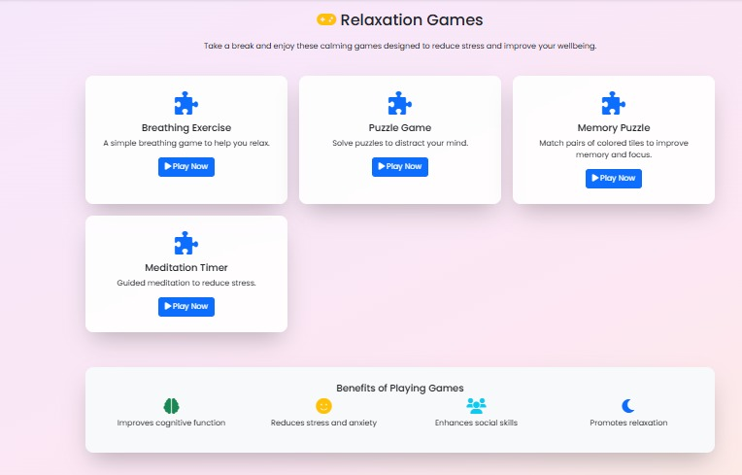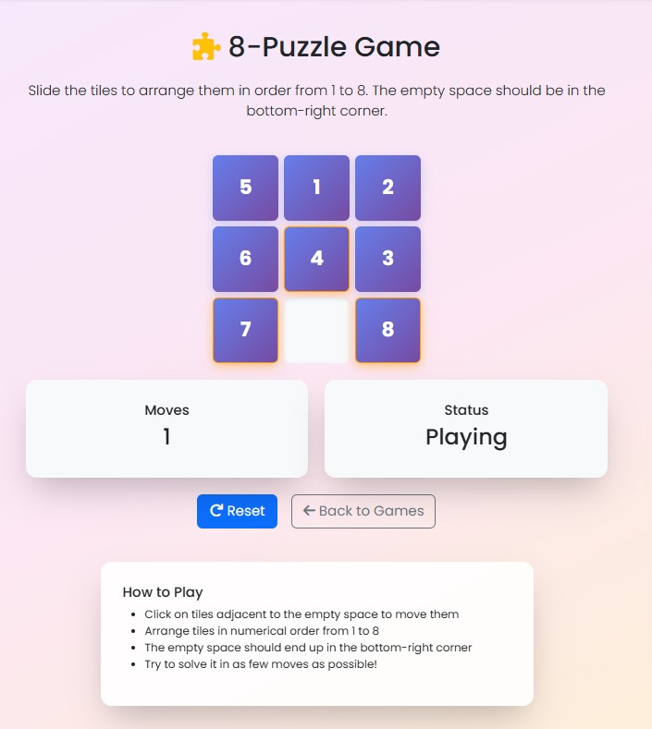
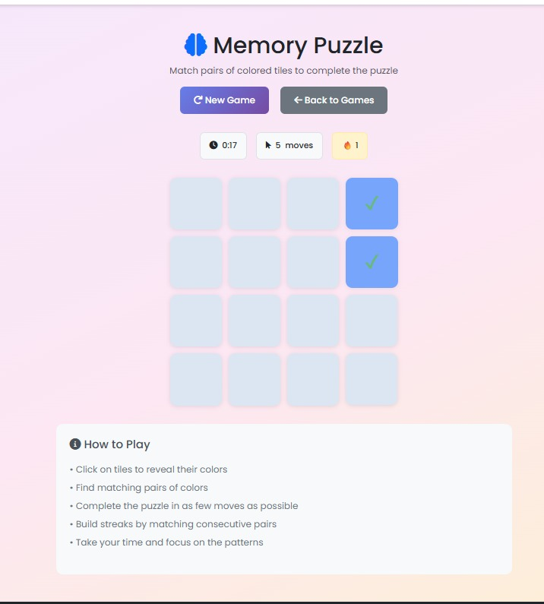


- GRAPH OF THE USER
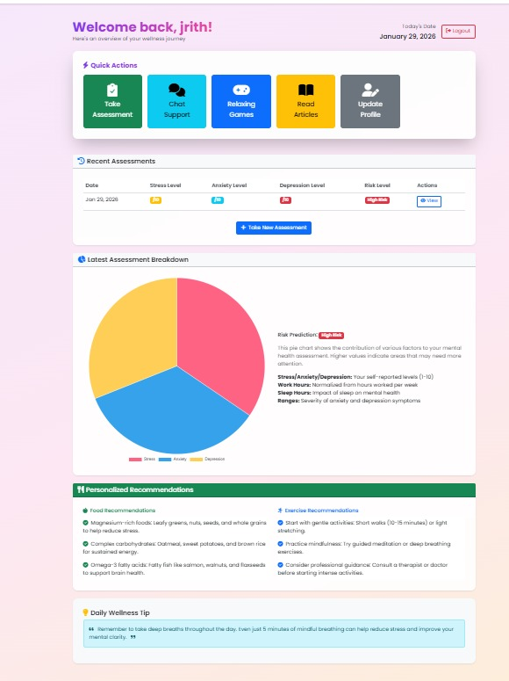
- ADMIN DASHBOARD
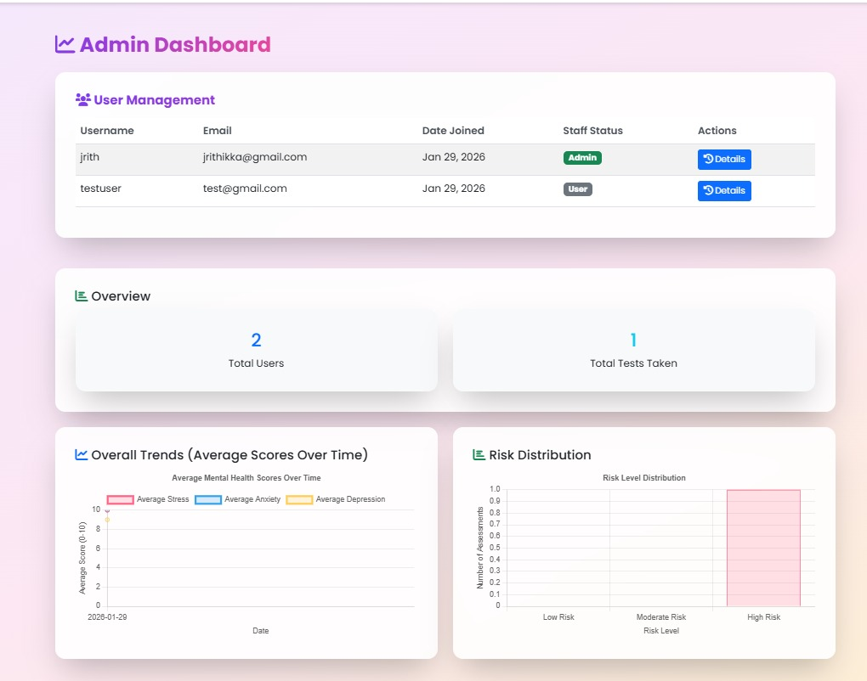

Overall Performance Summary of the Proposed System
The overall evaluation confirms that the proposed system:
- Accurately predicts mental health risk levels
- Provides immediate and personalized support
- Operates efficiently with minimal computational overhead
- Enhances accessibility to mental health resources
- Promotes early intervention and student well-being
The results demonstrate that combining machine learning, rule-based logic, and chatbot interaction offers a reliable and practical solution for addressing student mental health challenges.

CHAPTER 6: CONCLUSION
Summary of Findings
In conclusion, the proposed project “AI-Based Student Mental Health Support System” demonstrates the significant potential of Artificial Intelligence and Machine Learning in addressing mental health challenges among students. The system effectively integrates data preprocessing, Logistic Regression–based risk prediction, rule-based decision logic, and chatbot interaction to overcome limitations of traditional mental health support systems such as limited accessibility, delayed intervention, and social stigma.
Experimental evaluation using structured questionnaire data and simulated student inputs confirms that the proposed system can reliably classify students into different mental health risk categories. The use of Logistic Regression ensures transparent and interpretable predictions, which is essential for ethical compliance in mental health applications. The chatbot-based interface enables real-time interaction, allowing students to receive immediate guidance and emotional support in a confidential and non-judgmental environment.
Overall, the results demonstrate that the proposed system can serve as an effective decision-support tool for early mental health risk detection and intervention. The project validates the feasibility of AI-driven mental health assessment as a scalable, cost-effective, and accessible solution for academic institutions.
Summary of the Development Process
S.NO | Component | Description
A | Dataset | Student questionnaire and behavioral input data
B | Data Preprocessing | Cleaning, normalization, and feature selection
C | Machine Learning Model | Logistic Regression for risk prediction
D | Decision Logic | Rule-based feedback generation
E | Chatbot System | Personalized mental health support
F | Evaluation Metrics | Accuracy, Precision, Recall, F1-score, Confusion Matrix

Educational, and Societal Impact
From an educational perspective, the proposed system enhances student well-being by enabling early identification of mental health risks and promoting self-awareness. The system reduces dependency on manual counseling alone and supports institutions in prioritizing students who require immediate attention.
From a societal standpoint, the system contributes to reducing stigma associated with mental health by providing a private and supportive digital platform. The availability of continuous support encourages students to seek help without fear of judgment, thereby improving overall mental health awareness.

Future Enhancements and Scalability

While the proposed system demonstrates promising performance, several enhancements can be explored in future work:
1. Advanced NLP Integration
- Incorporation of sentiment analysis from free-text chat inputs.
- Improved emotional understanding using deep learning–based NLP models.
2. Multi-Language Support
- Expansion to support multiple regional languages.
- Improved accessibility for diverse student populations.
3. Mobile Application Deployment
- Development of a mobile-based mental health support application.
- Integration with institutional student portals.
4. Wearable and Activity-Based Data
- Inclusion of sleep, activity, and stress data from wearable devices.
- Improved real-time mental health monitoring.
5. Institutional Counseling Integration
- Seamless referral to professional counselors.
- Automated appointment scheduling and follow-up support.

CHAPTER 7: FUTURE WORK
The proposed AI-Based Student Mental Health Support System successfully demonstrates how artificial intelligence can be used to support early mental health risk detection and provide personalized emotional guidance to students. By integrating machine learning–based risk prediction, rule-based decision logic, and chatbot-driven interaction, the system offers a scalable and accessible alternative to traditional mental health support mechanisms. However, several future enhancements can further improve the system’s accuracy, adaptability, and real-world applicability.
One of the primary directions for future work is the integration of advanced Natural Language Processing (NLP) techniques. While the current system relies mainly on structured questionnaire responses, future versions can analyze free-text inputs from students using sentiment analysis, emotion detection, and contextual understanding. Deep learning–based NLP models such as transformers can be employed to capture subtle emotional cues, linguistic patterns, and stress indicators from student conversations, thereby improving the accuracy of mental health risk assessment.
Another significant enhancement involves the use of multimodal data sources. In addition to questionnaire responses, future systems can incorporate data from wearable devices and mobile sensors, such as sleep patterns, physical activity levels, screen time, and heart rate variability. Combining behavioral, physiological, and emotional data will enable more comprehensive mental health monitoring and early detection of psychological distress.
The system can also be extended to support adaptive and personalized learning-based models. Instead of using a static Logistic Regression model, future implementations may incorporate ensemble learning or deep learning models that continuously adapt to changing student behavior patterns. Personalized model tuning based on individual user history can further improve risk prediction accuracy while maintaining ethical transparency and interpretability.
Another important area for future development is mobile and web application deployment. The system can be transformed into a fully functional mobile application or web-based platform integrated with institutional student portals. This would allow seamless access to mental health support services anytime and anywhere, improving usability and engagement. Integration with appointment scheduling systems can enable direct referrals to counselors for high-risk students.
To enhance trust and ethical compliance, future versions can incorporate explainable AI (XAI) techniques. These techniques can provide students and mental health professionals with understandable explanations for risk predictions, improving transparency and confidence in the system’s recommendations. Visual explanations and simplified feedback can help users better understand their mental health status.
The system can also be expanded to support multi-language and cultural adaptability, making it suitable for diverse student populations. Language localization and culturally sensitive feedback mechanisms will help ensure inclusivity and broader adoption across institutions.
In the long term, the proposed system can evolve into a comprehensive digital mental health ecosystem, integrating institutional counseling services, teletherapy platforms, crisis helplines, and national mental health programs. By leveraging emerging technologies such as cloud computing, edge AI, and secure data-sharing frameworks, the system can provide real-time decision support while ensuring data privacy and security.
Overall, future enhancements aim to transform the proposed system into an intelligent, autonomous, and ethically responsible mental health support platform. With continuous research, real-world validation, and collaboration with educational institutions and mental health professionals, the system has the potential to significantly improve student well-being and contribute to healthier academic environments.

BIBLIOGRAPHY
- J. A. Shatte, D. M. Hutchinson, and S. J. Teague, “Machine learning in mental health: A scoping review of methods and applications,” Psychological Medicine, vol. 49, no. 9, pp. 1426–1448, 2019.
- P. K. Sharma and R. Gupta, “Artificial intelligence-based mental health assessment systems: A review,” IEEE Access, vol. 9, pp. 145231–145245, 2021.
- A. Miner, L. Hollingshead, J. H. Shaw, J. H. Wolff, and J. H. Beyer, “Using machine learning to assess depression and mental health from text,” IEEE Intelligent Systems, vol. 35, no. 4, pp. 72–80, 2020.
- S. D’Alfonso, “AI in mental health: Opportunities and challenges,” IEEE Technology and Society Magazine, vol. 39, no. 2, pp. 33–38, 2020.
- T. Fitzpatrick, A. Darcy, and M. Vierhile, “Delivering cognitive behavior therapy to young adults with depression and anxiety using a fully automated conversational agent,” JMIR Mental Health, vol. 4, no. 2, e19, 2017.
- K. Inkster, M. Sarda, and V. Subramanian, “An empathy-driven, conversational artificial intelligence agent (Wysa) for digital mental well-being,” JMIR Mental Health, vol. 5, no. 4, e12106, 2018.
- N. B. Shah, M. M. Patel, and R. K. Patel, “Mental health prediction using logistic regression and machine learning techniques,” International Journal of Computer Applications, vol. 182, no. 30, pp. 1–6, 2019.
- A. B. Torres and L. G. Vargas, “Chatbot-based mental health assistance using NLP and machine learning,” in Proceedings of the IEEE International Conference on Computational Intelligence and Computing Research (ICCIC), IEEE, 2022, pp. 1–6.
- S. Haque, M. S. Hossain, and A. El Saddik, “AI-based mental health monitoring systems: A survey,” IEEE Transactions on Computational Social Systems, vol. 8, no. 3, pp. 691–704, 2021.
- World Health Organization, “Mental health of students in educational institutions,” WHO Technical Report, 2022.
- J. Kumar and S. Ravi, “Student stress detection and analysis using machine learning techniques,” International Journal of Advanced Research in Computer Science, vol. 11, no. 5, pp. 45–51, 2020.
APPENDICES
IMPLEMENTATION OF THE AI-BASED STUDENT MENTAL HEALTH SUPPORT SYSTEM
The proposed AI-Based Student Mental Health Support System is an intelligent and automated solution designed to support early identification of mental health risks among students and provide personalized emotional guidance. The system integrates machine learning–based risk prediction, data preprocessing, rule-based decision logic, and chatbot-driven interaction into a unified framework that promotes accessibility, confidentiality, and timely intervention.
A key component of the system is the Python-based backend processing module, which functions as the core inference and decision engine. This module handles student data preprocessing, mental health risk prediction using Logistic Regression, rule-based risk classification, and personalized chatbot feedback generation. The modular architecture ensures scalability, maintainability, and seamless integration with future mobile or web-based mental health platforms.
Machine Learning Inference Module for Mental Health Risk Prediction
The backend inference system is implemented using Python and machine learning libraries such as Scikit-learn, NumPy, and Pandas. The inference pipeline is designed to accept structured student questionnaire data as input and produce outputs including predicted mental health risk level and personalized guidance.
Initial Setup
The implementation begins by importing essential Python libraries and initializing the model environment:
import numpy as np
import pandas as pd
from sklearn.linear_model import LogisticRegression
from sklearn.preprocessing import StandardScaler
Data Preprocessing and Normalization
Student mental health data often contains variations in scale and missing values that can negatively affect prediction accuracy. To address this, preprocessing steps such as cleaning, normalization, and feature selection are applied.
Preprocessing Function
def preprocess_data(data):
scaler = StandardScaler()
data_scaled = scaler.fit_transform(data)
return data_scaled
Mental Health Risk Prediction Using Logistic Regression
The core classification component uses Logistic Regression, chosen for its simplicity, efficiency, and interpretability. The model predicts the probability of a student belonging to a high mental health risk category.
Model Training
model = LogisticRegression()
model.fit(X_train, y_train)
Probability-Based Risk Prediction
Instead of generating rigid class labels, the system produces probabilistic outputs that reflect confidence levels in predictions.
def predict_risk(model, input_data):
probability = model.predict_proba(input_data)[0][1]
return probability
Rule-Based Risk Classification
To enhance interpretability and reliability, a rule-based decision layer is applied on top of the machine learning output.
def classify_risk(probability):
if probability > 0.75:
return "High Risk"
elif probability > 0.40:
return "Moderate Risk"
else:
return "Low Risk"
Chatbot-Based Personalized Feedback Generation
Based on the classified risk level, the system generates personalized feedback using a chatbot interface.
def chatbot_response(risk_level):
if risk_level == "High Risk":
return "We recommend speaking with a counselor. You are not alone."
elif risk_level == "Moderate Risk":
return "Try stress management and relaxation techniques."
else:
return "Keep maintaining a healthy routine and positive habits."
End-to-End Inference Workflow
The complete system pipeline integrates preprocessing, risk prediction, classification, and chatbot feedback into a single workflow:
input_data = preprocess_data(student_input)
probability = predict_risk(model, input_data)
risk_level = classify_risk(probability)
response = chatbot_response(risk_level)

print("Mental Health Risk Level:", risk_level)
print("Chatbot Response:", response)
System Reliability and Extensibility
The implementation ensures:
• Robust preprocessing of student data
• Transparent and interpretable machine learning predictions
• Ethical decision-making through rule-based logic
• Real-time and confidential chatbot interaction
• Scalability for future enhancements
The modular design allows individual components to be updated independently, supporting long-term maintenance and extensibility.
Conclusion of Appendix
This appendix presents the practical implementation of the AI-Based Student Mental Health Support System, demonstrating how machine learning, rule-based logic, and chatbot interaction are combined to create a reliable and accessible mental health support tool. The implementation confirms the feasibility of deploying AI-driven mental health assessment systems in real-world academic environments.
Furthermore, the flexible architecture enables future enhancements such as advanced NLP integration, mobile application deployment, multi-language support, and institutional counseling system integration. This reinforces the system’s potential as a scalable and ethically responsible mental health support solution.

